REGIONAL ASSESSMENT TEMPLATE

LOCATION OF THE REGION
Author contact information
Name
E-mail
Telephone
Organisation

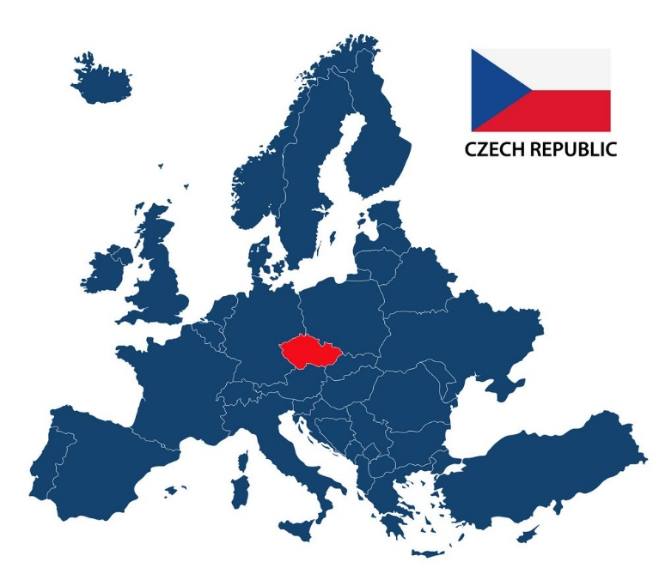

PART 1 – MAIN ECONOMIC INDICATORS IN THE REGION

Gross Domestic Product in EURO | 2015 | 2016 | 2017 | 2018 | 2019
Gross Domestic Product per capita in EURO | 2015 | 2016 | 2017 | 2018 | 2019
Inflation % | 2015 | 2016 | 2017 | 2018 | 2019
Unemployment rate % | 2015 | 2016 | 2017 | 2018 | 2019
Monthly salary in EURO (Median) | 2015 | 2016 | 2017 | 2018 | 2019
Sold production of industry per capita in EURO | 2015 | 2016 | 2017 | 2018 | 2019
Renewable energy share in electricity production % | 2015 | 2016 | 2017 | 2018 | 2019
Emission of CO2 tons/year | 2015 | 2016 | 2017 | 2018 | 2019
Planned emission reduction by 2030 at the national level %
Share of Industry to total GDP | 2015 | 2016 | 2017 | 2018 | 2019

PART 2 – INDUSTRY AND RES POTENTIAL IN THE REGION
Predominant industry sectors in the region | 1.  2.  3.  4.
Type and share of energy sources used in industry | coal %  natural gas %  petroleum %  RES %  other, what kind? ..................................................%
A type of renewable energy used in industry | ☐ solar energy  ☐ geothermal energy  ☐ environmental energy  ☐ biomass  ☐ biogas  ☐ wind energy  ☐ hydropower  ☐ other, what kind? ................................................
Installed capacity at individual sources in the region, including data source [MW] | Biogas power plants  Biomass power plants  Solar power plants  Wind power plants  Hydroelectric power stations  Power plants implementing co-firing technologies
Total installed capacity of renewable energy sources in the region in MW
PREDOMINAT INDUSTRY SECTOR No. 1 (for example FOOD INDUSTRY)

Investment costs in EURO
Investment scope | (For example: modernization of technological lines, technological heat recovery, heating / DHW / cooling (heat pumps, solar collectors, PV, thermal modernization, trigeneration), and lighting (energy-saving power supply), energy monitoring)
Energy efficiency %
Annual Energy efficiency in MWh/year
Reduction of Energy costs
Reduction of CO2 Emissions tons/year
Reduction costs calculated by the DGC method tons/year
Type and % share of energy consumption in key industry sectors | space heating  domestic hot water  technological goals  ventilation / air conditioning  transport

PREDOMINAT INDUSTRY SECTOR No. 2

Investment costs in EURO
Investment scope | (For example: modernization of technological lines, technological heat recovery, heating / DHW / cooling (heat pumps, solar collectors, PV, thermal modernization, trigeneration), and lighting (energy-saving power supply), energy monitoring)
Energy efficiency %
Annual Energy efficiency in MWh/year
Reduction of Energy costs
Reduction of CO2 Emissions tons/year
Reduction costs calculated by the DGC method tons/year
Type and % share of energy consumption in key industry sectors | space heating  domestic hot water  technological goals  ventilation / air conditioning  transport

PART 3 – RES FUNDING SOURCES IN THE REGION
What were the sources of renewable energy financing in industry in the region in 2014-2020?
The amount of funds in EURO
Type of beneficiary (SME, large industry, agriculture)

What were energy efficiency financing in industry in the region in 2014-2020?
The amount of funds

Type of beneficiary (SME, large industry, agriculture)

What are the planned sources of renewable energy financing in industry in the region in 2021-2027, the planned amount of funds?
The amount of funds in EURO
Type of beneficiary (SME, large industry, agriculture)

What are the planned energy efficiency financing in industry in the region in 2021-2027, the planned amount of funds?
The amount of funds in EURO
Type of beneficiary (SME, large industry, agriculture)

PART 4 – COMMENTS FOR THE RA IN THE REGION
Try to evaluate the RES in your region by the SWOT analysis, where do you see the strengths, opportunities, weaknesses and threats for usage of the RES in your region.

 | Helpful  (to achieving the objective) | Harmful  (to achieving the objective)
Internal origin  (atributes of the RES usage in industry) | S  STRENGTHS | W  WEAKNESSES
External origin  (atributes of the environment) | O  OPPORTUNITIES | T  THREATS

